Bank Deposit

This query calculates the total amount deposited by all clients into their bank deposit accounts using the SUM() function.

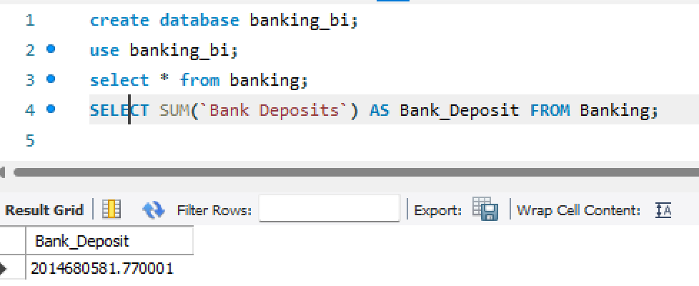
Bank Loan

This query computes the total value of all bank loans issued to clients by summing the Bank Loans column.
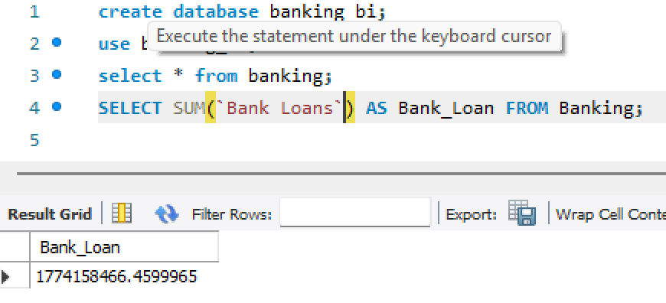

Business Lending

This query calculates the total amount of business loans provided to customers. It is useful for analyzing commercial lending activities.
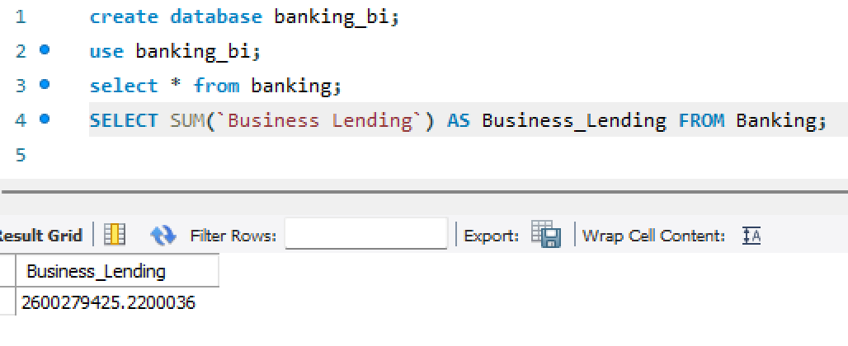
Checking Accounts

This query sums the balances of all checking accounts to determine the total funds held in checking accounts.
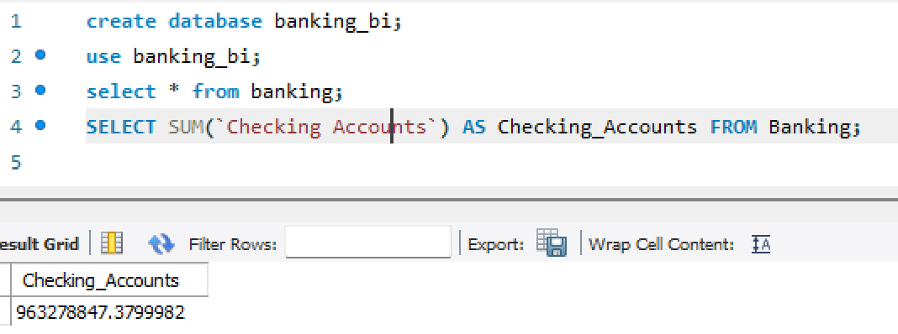

Credit Card Balance

This query calculates the total outstanding balance across all client credit cards.

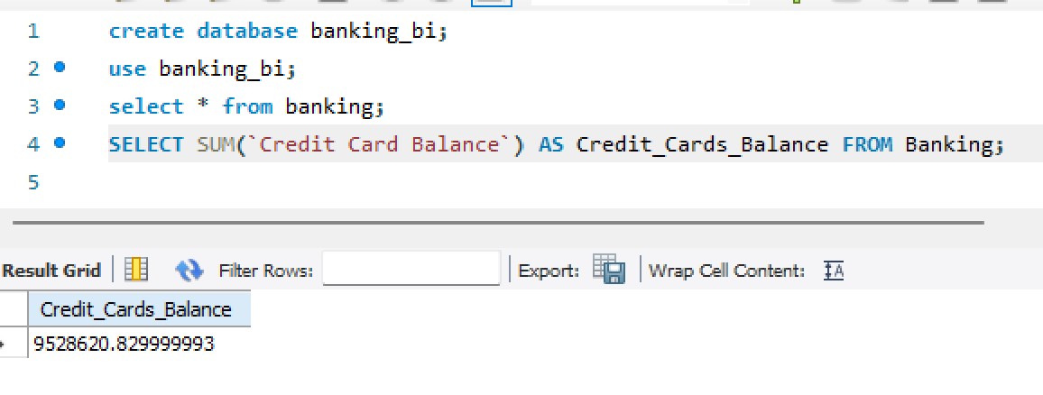

Foreign Currency Account

This query computes the total balance held in foreign currency accounts by summing all account values.
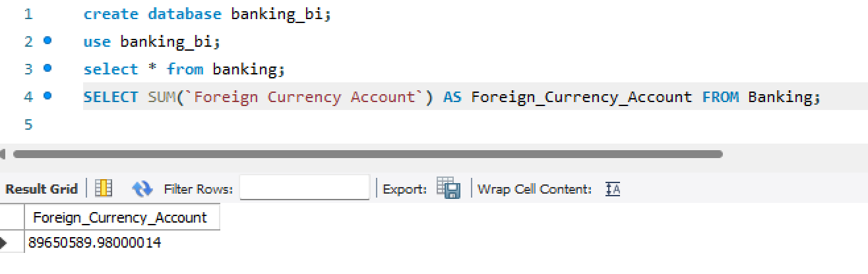
Savings Account

This query calculates the total balance across all savings accounts maintained by clients.

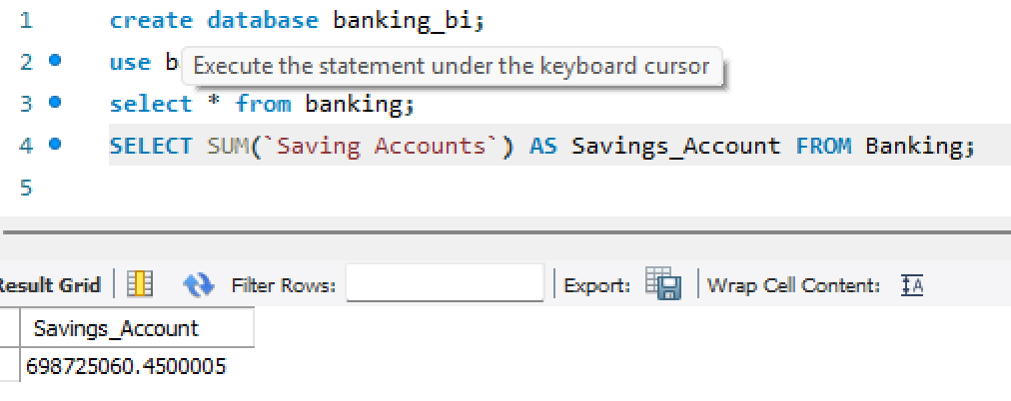

Total CC Amount

This query sums the total amount associated with all credit cards issued to clients, providing an overview of credit card usage.
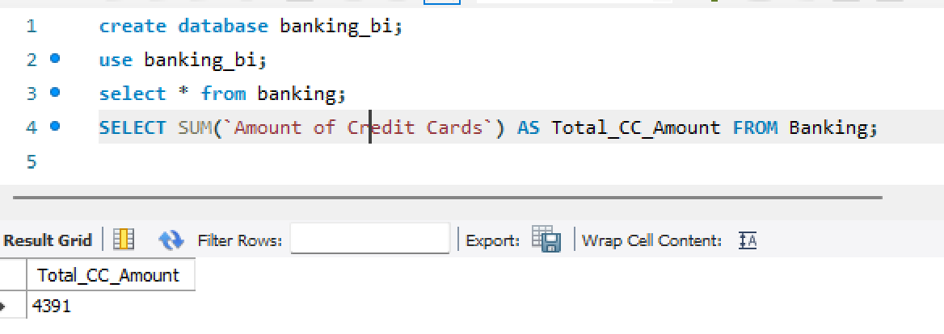
Total Clients

This query counts the total number of unique clients in the banking dataset using COUNT(DISTINCT Client_ID). It helps determine the overall customer base.
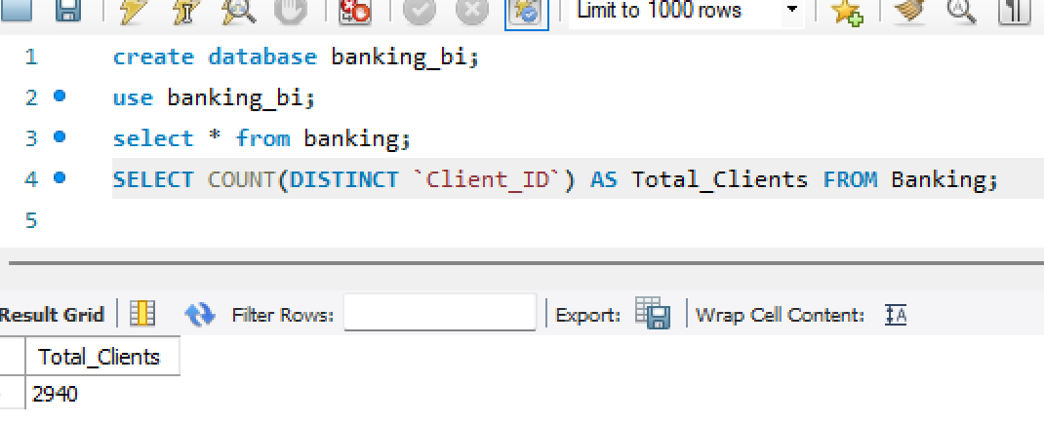
Total Deposit

This query calculates the combined value of all client deposits by adding bank deposits, savings accounts, foreign currency accounts, and checking account balances. It provides the overall deposit portfolio of the bank.
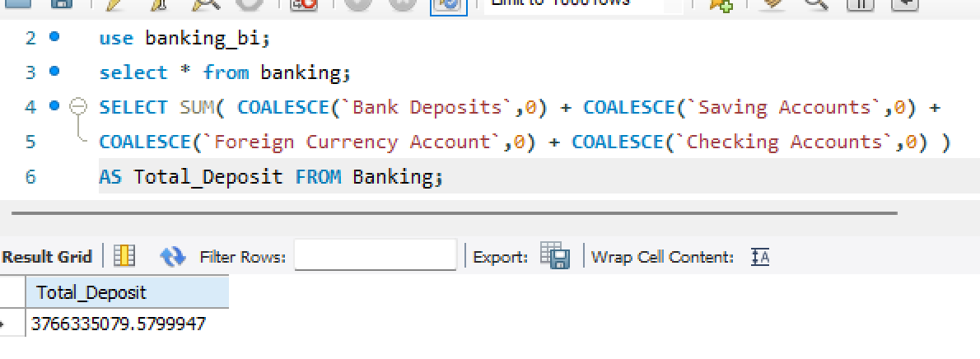
Total Loan

This query calculates the bank's total lending exposure by summing bank loans, business lending, and credit card balances for all clients.

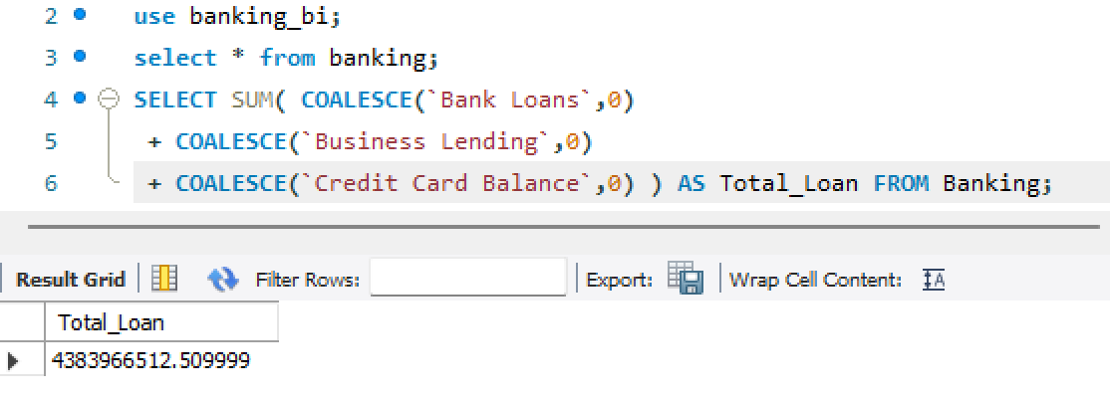

Total Fees

This query calculates the total processing fees collected by multiplying each client's total loan amount by its corresponding processing fee and then summing the results.
